

Benha University
Faculty of Engineering, Shoubra
Computer Systems Department

Charity organization System
El-Fath Legitimacy Association

Team Members
- محمود محمد طه أبوعياد
- حسام الدين أنسى
- محمد على يوسف الخياط

Supervised By:
Dr. Abdel-Wahab EL-Sammak
End. Mahmoud Ramadan

2015 - 2016

Acknowledgments:

First of all, we would like to express our gratitude and appreciation for our supervisor, Dr. Abdel-Wahab EL-Sammak for his professional guidance and insightful advices.
Also we must all thank our . instructor End. Mahmoud Ramadan for his continuous assistance and support.
Special thanks for Mr.Fathi Mohammed Mahmoud Abdel-Raoof from El-Fath Charity organization for his great help and support during the system requirement determination process of the analysis/ Design/ Programming phase of the project.

Faculty of Engineering, Shoubra
2015 - 2016

- محمود محمد طه أبوعياد
- حسام الدين أنسى
- محمد على يوسف الخياط

Contents

Acknowledgement I
Contents II
Abstract III
Project Plan IIII

Chapter 1 System Requirements
  - System Scope
  - Business Objectives
1.3 Facts Finding
1.3.1 Interviews
1.3.2 Problems of the Current System
1.3.3 Forms & Reports of the Current System
1.4 Development Process

Chapter 2 System Analysis
  - Used Methodology
  - Analysis Models
  - Processes Logic

Chapter 3 System Design
  - System Database Design
    - ER Diagram
3.1.2 Tables Design
3.2 User Interface Design
3.2.1 Summary of Screens (Pages)
3.2.2 Forms (Pages) Design
3.2.3 Reports Design

Chapter 4 System implementation
  - Used Technologies
4.1.1 Database
4.1.2 Programming
4.1.3 Reporting
  - System Implementation Plan
4.2.1 Administration
4.2.2 Basic System Data
4.2.3 Transactions
  - System Messages

Chapter 5 System Testing
  - Testing Check List
  - Test Cases

Chapter 6 Future Work & Conclusion

Appendix A Source Code Listing

Appendix B Installation Guide

Appendix C User Manual

Abstract

this is a SYSTEM ANALYSIS project about charity organization tracking its different activities and updating its used methods saving time and money

Project Plan

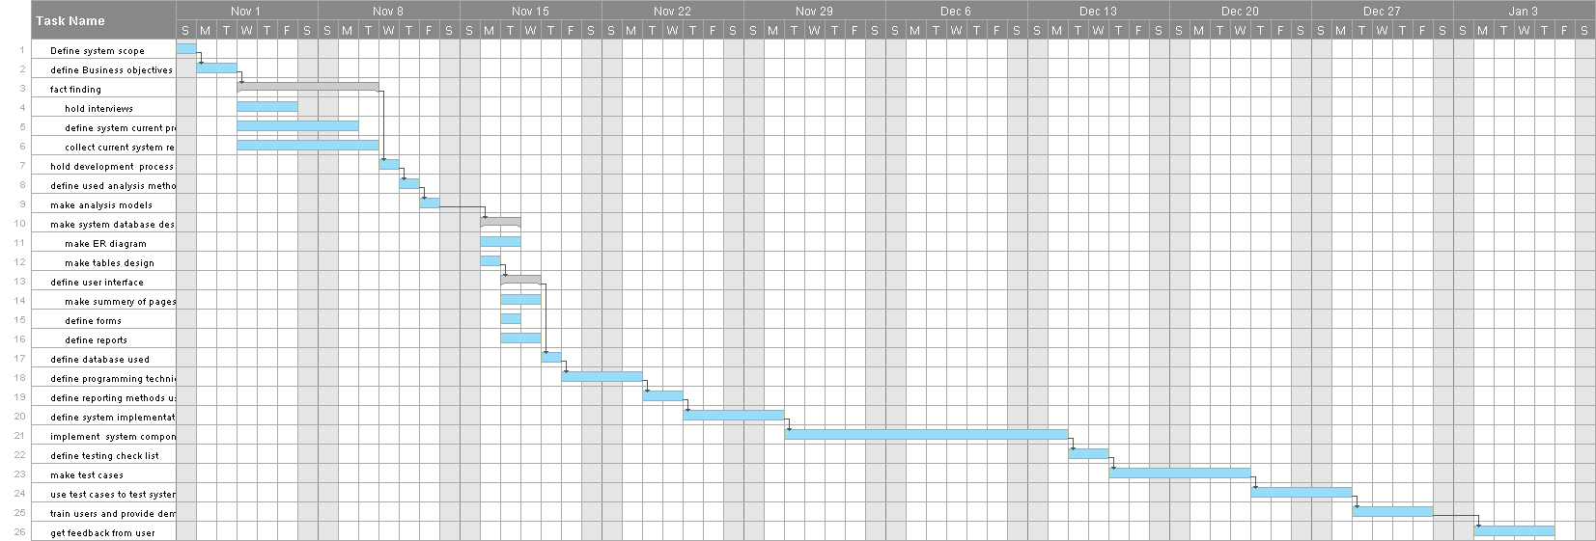

Chapter 1

System Requirements

1.1 System scope:

- Our El-Fath charity organization is general charity that help poor people and have many activities like: money for people - Ezzakah - , old cloths enhancement, meat for poor people in Feast

- our scope is to track any money and financial affairs as input for the charity in way of donation or as output in shape of money or services or products

- anther objective is to track any activity by this organization helping poor people

- monitor and control the following processes
- orphans helping
- girl orphans marriage support
- Quran learning
- Islamic science teaching
- cancer patient people caring
- clothes mini-factory
- pharmacy providing medicine for free for poor people
- RAMADAN AND FEASTS CLOTHES AND FOOD FOR POOR PEOPLE
- receive and send donations from donors and to poor people

  - Business Objectives:

Our project covers a wide scope designed to implement computerized system for the following Requirements:

- Functional Requirements
- Save all donation and donors’ names and address to get money from them monthly

- Save all poor people’s names and address to get money and services with equal amount

- Get full system describing all processes in the organization

- Provide save and accurate way to get all organizations money and need for money

- Provide fast way to know the most relevant actions the charity take depending on the current season of year and the current material the organization has

- Nonfunctional Requirements
- Keep system save from errors and giving somebody a lot and let others complain from starvation

- Implement system so it can be updated easily

- Protect the charity organization save from rubbers and layers

- Accurate information about each event and each member data

- Portability so system can work on more than one system

- Provide high speed with large data system

- The system can be accesses from more than one place by web with the same high speed

1.3 Facts Finding

1.3.1 Interviews

Interview Agenda
Date : 16/11/2015 Time: 4:00 PM
Place: El-Fath charity organization
Participants: El-Fath charity head
Name: Mr. Fathi Mohammed Moahmoud Job: El-Fath charity head
1. Mr. Samer Job: worker and team leader in organization
2. Mr. Baraka Job: financial department leader
3.eng. Mahmoud Mohammed Taha
4. eng. Mohammed Ali Yousef El-Khaiat
Objectives: gathering information about El-Fath charity

-find the methods for achieving different activities
-check the system used currently with the charity
-detect the needs of the system owners
-
-

Documents to be Prepared:
-documents about the charity organizations
-invoices for getting money from donors
-
-

Interview Summary:

- we have detected that the charity have various activities like:
- orphans helping
- girl orphans marriage support
- Quran learning
- Islamic science teaching
- cancer patient people caring
- clothes mini-factory
- pharmacy providing medicine for free for poor people
- RAMADAN AND FEASTS CLOTHES AND FOOD FOR POOR PEOPLE
- receive and send donations from donors and to poor people

- the charity has many ways for achieving this activities like
- using volunteers’ effort
- pay for worker to do some activities
- co-operate with other charities to achieve big specified goal

- rules and discipline followed of the organizations:
- fair handling for poor people
- provide services for all poor people of all genders or religion
- never interfere in political or non-ethical affairs

1.3.2 Problems of the Current System

- Not up-to-date and does not use modern technologies
- Not well organized
- Not compatible for future updates
- May non-honest people get more than others
- Need accurate calculations
- Need to be easy accesses by the users of the systems
- The users of the system are not very good in using modern technologies
- Users of the system need training to be accustomed to using the system
- Need to keep track of the material than can corrupt with time like: medicine or food

1.3.3 Forms & Reports of the Current System

we have collected several types of reports about the systems like:
- tables of the poor and patient people:
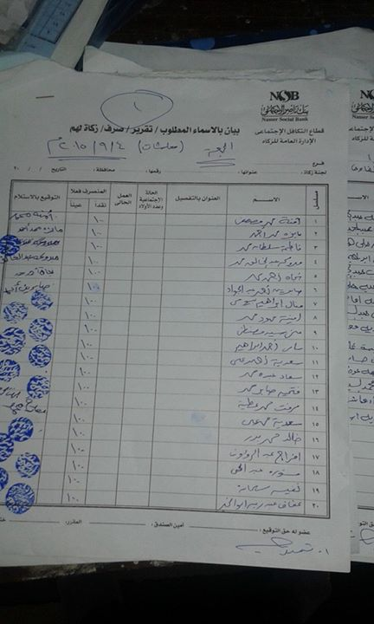

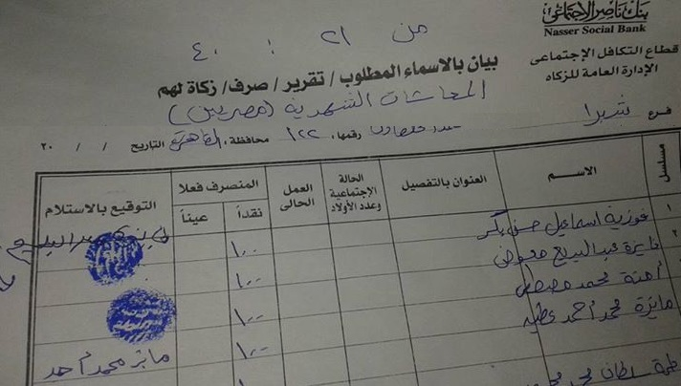

- some invoices of the donation receiving:
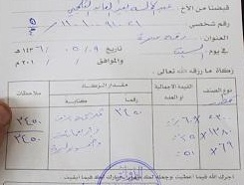

- some formal paper for each poor person
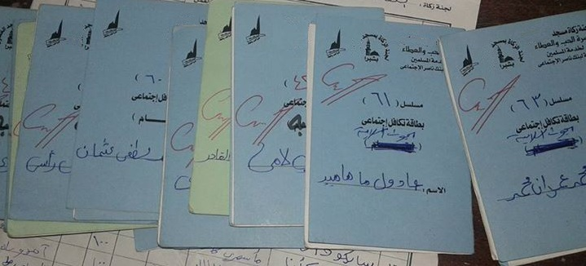
- some activities announcement:



- table of services for cancer patient people
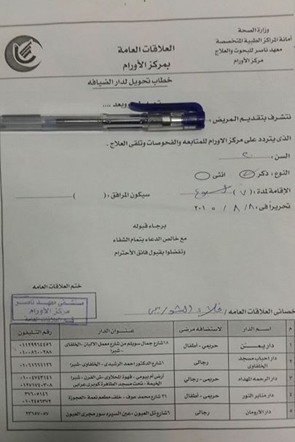

1.4 Development Process

We decided to apply the Iterative development technique.
The reason for using this technique is

- our system has changing requirements which needs continuous planning – analyzing - implantation and control
- our project provides high risk and technical needs
- our project is not well defined as it contains more than one sub-organization in our organization
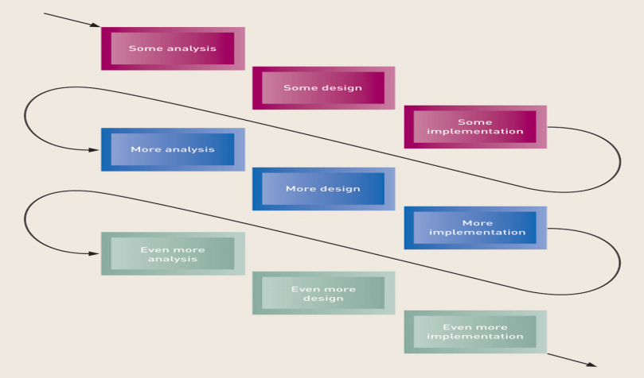
Implementation
System Requirements
Testing
Analysis
Deign

Figure 1.1: Development Process Phases

Chapter 2

System Analysis

2.1 Used Methodology:

We have chosen Object-Oriented approach in our project

- Viewing information system as collection of interacting objects that work together facilities accomplishing out tasks

- Object-oriented analysis (OOA)‏: Defines types of objects users deal with and shows use cases are required to complete tasks

- We also have chosen SCRUM as our software development methodology
- Reasons for using SCRUM:
  - A development team works as a unit to reach a common goal

- some of SCRUM advantages:
- Time saving
b- Higher quality
c- More work and fewer meetings
d- Easier feedback

- Product owner: EL-Fath charity oragnization
- Development team:
- Mahmoud Mohammed Taha
- Mohammed Ali Yousf El-KHaiat
- Hossam El-Den Onsy
- Scrum master: Mahmoud Mohammed Taha
2.2 Analysis Models

Main Actors
- Poor
- Volunteer
- Employee
- Orphans
- Girl orphans
- Teachers
- Student
- Pharmacist
- Patient

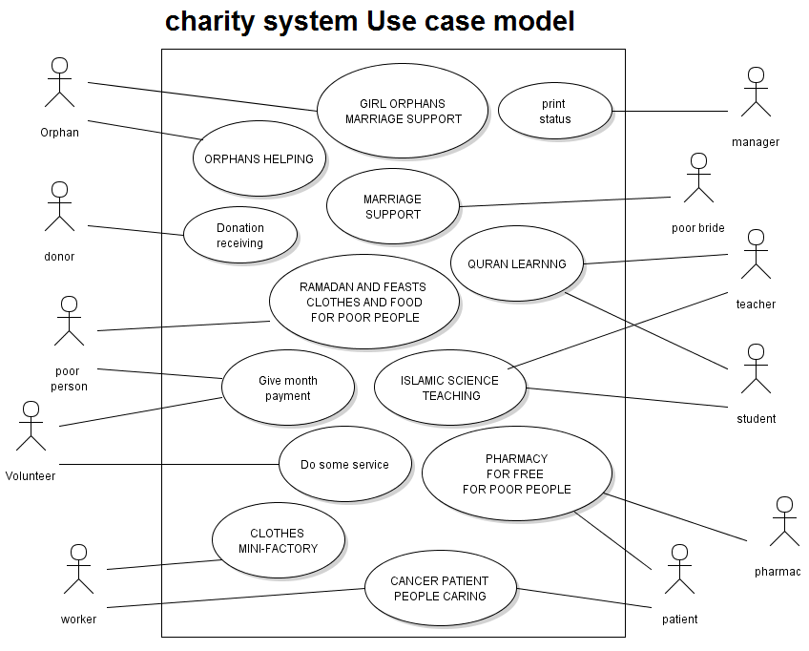

Learning subsystem event table
Destination | Response | Use Case | Source | Trigger | Event
Student | student ticket | Get ticket | Student | Request a ticket | 1-Student want to get a ticket for a session
System | Student avability to ticket | Check student behavior | System | Request a ticket | 2-Check student behavior
Teacher | Sessions schedule | Search for a time for session | Teacher | Request time for new session | 3-Teacher wants to search for time for session
Student | Certification | Get a certificate | Student | Demand a certificate | 4- student wants to get a certificate
manager | Learning subsystem report | Get report | manager | Request report | 5- manager wants report on the learning system

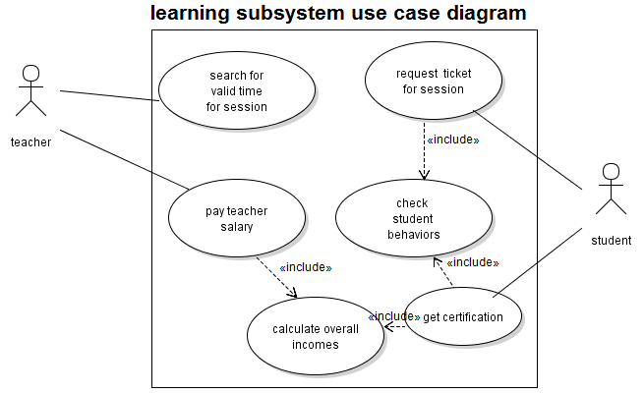
Medical subsystem event table
Destination | Response | Use Case | Source | Trigger | Event
Patient | Room availability | Request a room | Patient | Room request | 1-patient want take room
Patient | medicine availability | Request a medicine | Patient | Request a medicine | 2- patient want a medicine
--- | list of medicines updated | Add new medicine | Pharmacist | New medicine was arrived | 3- pharmacist want to add a new medicine
Pharmacist | Data of medicine | Check medicine data | Pharmacist | Request medicine data | 4- pharmacist check a data for a medicine

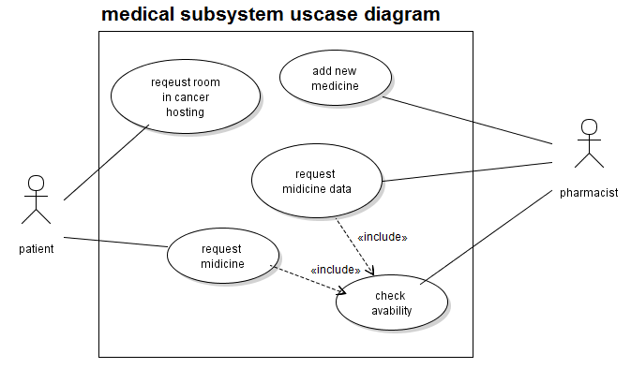

Fundraising subsystem event table
Destination | Response | Use Case | Source | Trigger | Event
Donor | receipt | Request adding donation | Donor | Request adding donation | 1-donor wants to add new donation
--- | Update system data | Adding monthly donations | Volunteer | Request adding monthly donation | 3-volunteer wants to add monthly donation
Anther charity | Donation acceptance | Adding donation budget | Anther charity | Request adding donation | 2- an organization wants to give donation to charity
Manager | reports | Generating reports | Manager | Request donation status reports | 4-manager wants report about all new donations

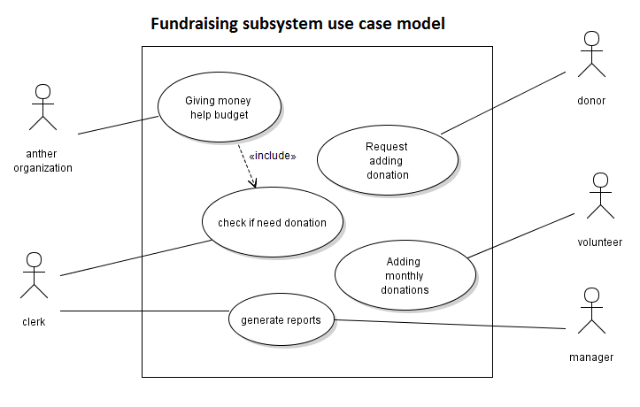

Orphans and marriage helping subsystem event table
Destination | Response | Use Case | Source | Trigger | Event
Poor person | Money help | Giving money help | Poor person | Request money help | 1-poor people request money help
Girl orphan | Marriage needs | Giving marriage help | Girl orphan | Request marriage help | 2- girl orphan/ poor bride request marriage help
--- | Add new poor person data to the system data | Adding new poor person | Volunteer | New poor person added | 3- volunteer add data for poor person
volunteer | Poor or orphan data | Do social research on an orphan | volunteer | Request poor person data | 4- volunteer wants to do social research on an orphan or poor person
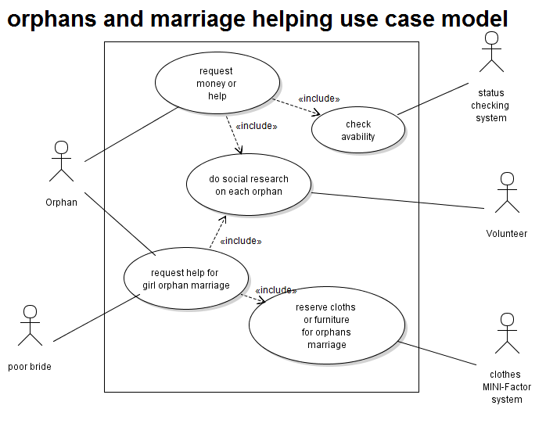

Processes Logic

- Scenario description for request money help

Use case name: | request money help
Actors: | - Orphan  - Status checking system  - Volunteer
Pre-condition: | Orphan is registered in the data system of the charity
Post-condition: | Add the given help for the orphan in his file in the charity
Flow of activity: | Actor: | System:
Flow of activity: | - Orphan add request for specified amount of money | - system checks the availability money in charity  - system checks the social status of orphan  - the system give the requested money to orphan
Exception: | - if no money available the system will put this request on the waiting list  - if this is a cheating request the system halt it

- Scenario description for request marriage help

Use case name: | request marriage help
Actors: | - Girl Orphan  - Status checking system  - Volunteer
Pre-condition: | Girl Orphan is registered in the data system of the charity
Post-condition: | Add the given help for the girl orphan in his file in the charity
Flow of activity: | Actor: | System:
Flow of activity: | - Girl orphan adds request for specified amount of money | - system checks the availability money in charity  - system checks the social status of girl orphan  - the system give the requested money to orphan
Exception: | 1.1 if no money or furniture available the system will put this request on the waiting list  - if this is a cheating request the system halt it

- Scenario description for adding donation

Use case name: | Addition of donation
Actors: | - Donor  - System clerk
Pre-condition: | The charity accepts donation currently
Post-condition: | System saves donors data for future processes
Flow of activity: | Actor: | System:
Flow of activity: | - Donor asks to add new donation | - System add the count of donation to all system budget  - System prints invoice for the donor
Exception: | - If charity doesn’t accept donation reject the donor
- Request session time activity diagram:
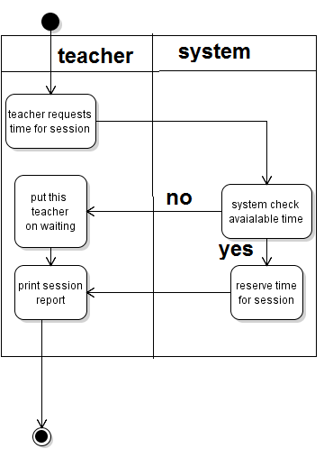

- Request session ticket activity diagram:
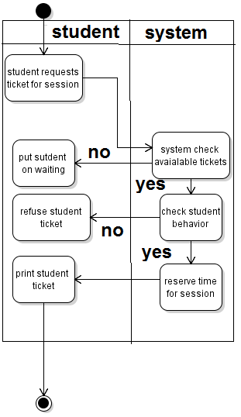

- Medicine state diagram
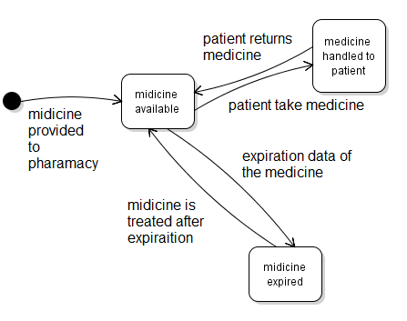

- Sequence diagram for room request in cancer hospital
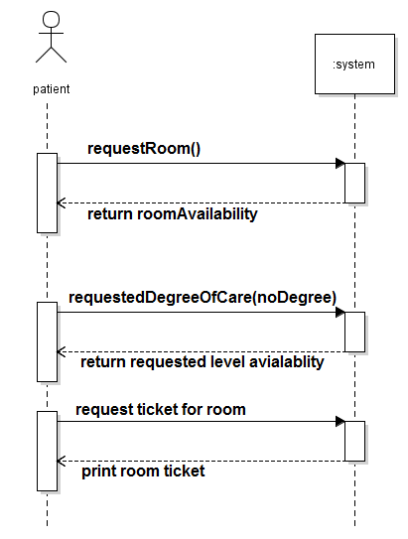

Structured Analysis:

- Traditional approach
- Data Flow diagrams

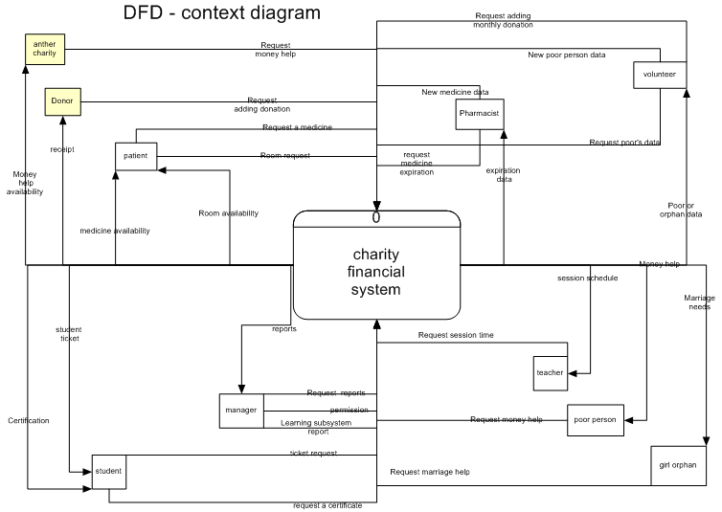

As we have four to five big subsystem we made overall diagram to all of them

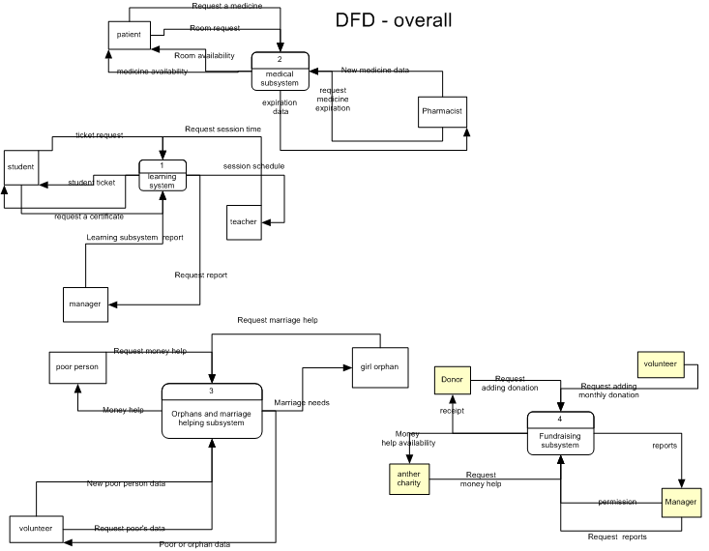

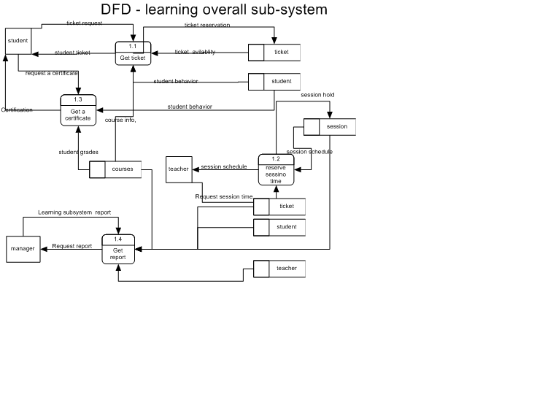

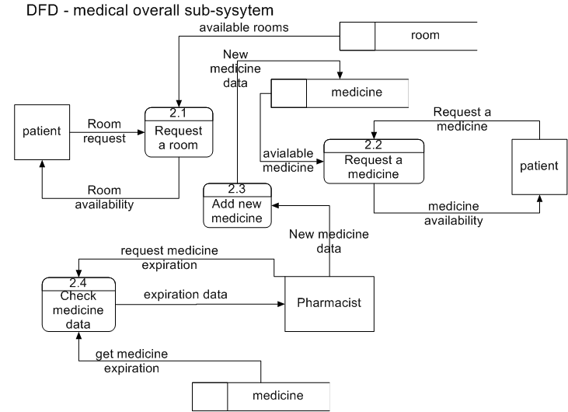

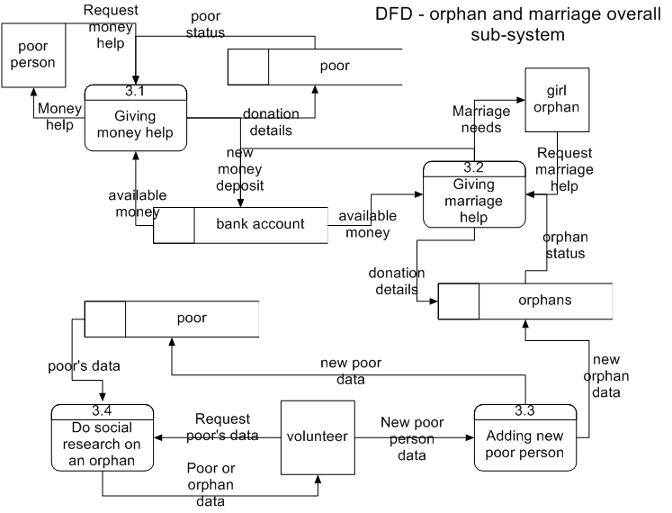

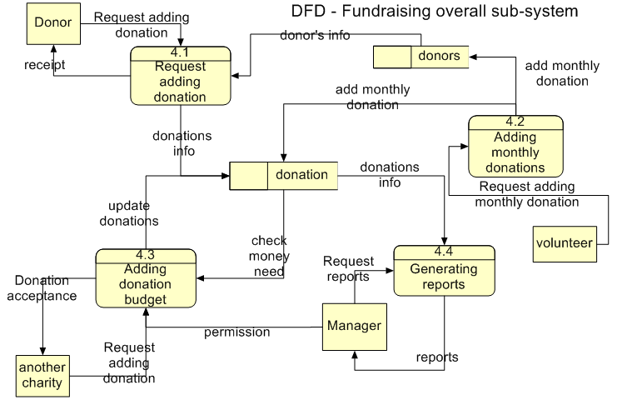

Detailed DFDs for the learning sub-system with their descriptions:
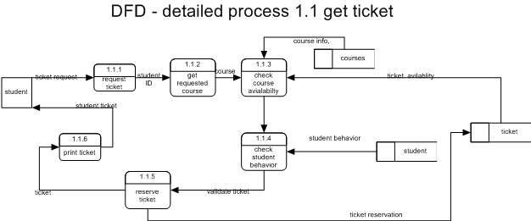

Process 1.1.3 check course availability
IF course not exist
Announce student no such course
End Process
Else IF course has no free tickets
Announce student no free tickets
End Process
Else
Validate course and free tickets
End process
Process 1.1.4 check student behavior
IF student is not successful
Announce student he not allowed to register
End process
Else
Validate student behavior
End IF
End Process

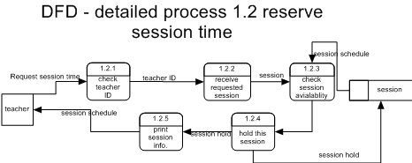

Process 1.2.3 check session availability
IF session time is free
Hold this time
End Process
Else
Announce teacher this time is not free
End Process

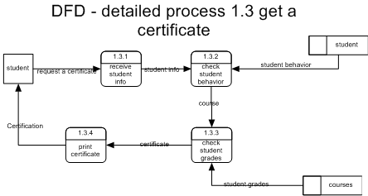
Process 1.3.2 check student behavior
IF student is not successful
Announce student he not allowed to register
End process
Else
Validate student behavior
End IF
End Process
Process 1.3.3 check student grades
IF course not exist
Announce student no such course
End Process
Else IF student failed the exam
Announce student he have failed the exam
End Process
Else
Validate course and certificate info
End process
Detailed DFDs for the medical sub-system with their descriptions:
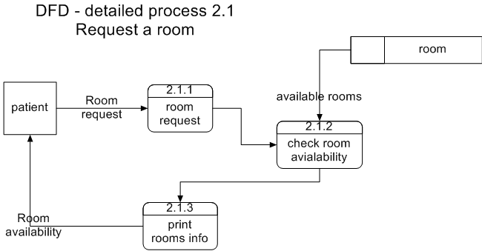

Process 2.1.2 check room availability
IF room is free
Hold this room
Else
Announce user this room is not free
End Process

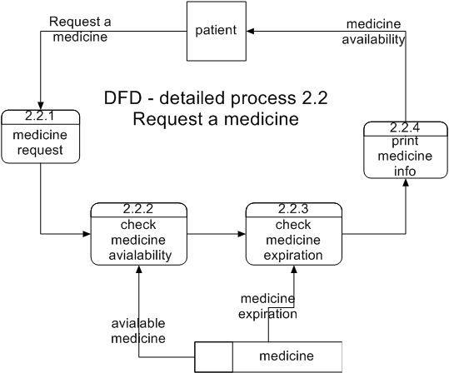

Process 2.2.2 check medicine availability
IF medicine is available
Print no of items
Else
Announce user medicine is not available
End Process
Process 2.2.3 check medicine expiration
IF medicine is not expired
Hold this medicine
Else
Announce user medicine is not expired
End Process
Detailed DFDs for the marriage and orphans helping sub-system with their descriptions:

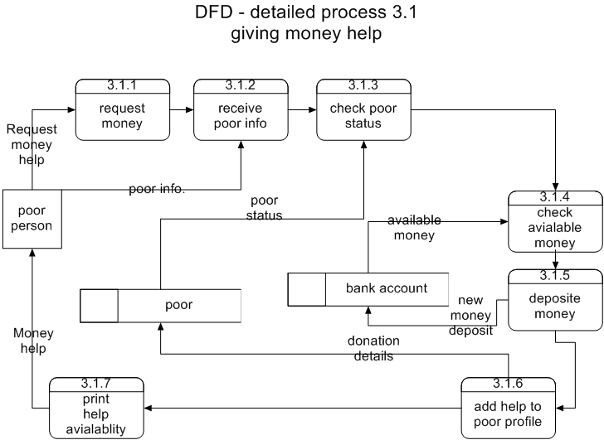

Process 3.1.3 check poor status
IF poor is really in need
Continue request procedures
Else
Refuse money request
End Process
Process 3.1.4 check money available
IF money is available
Accept money request
Else
Refuse money request
End Process

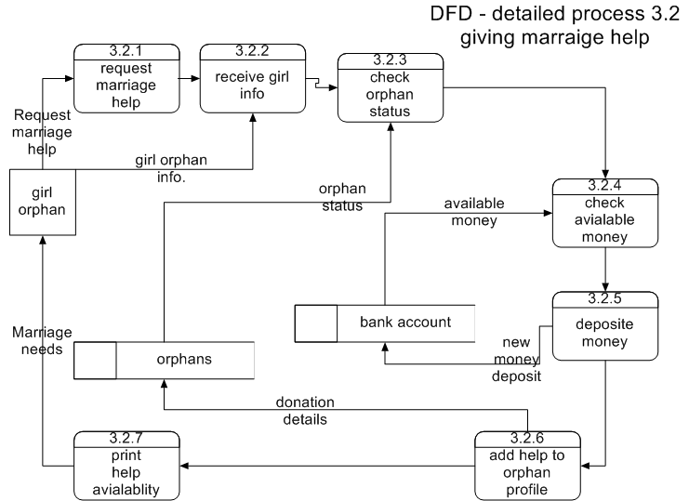

Process 3.1.3 check orphans status
IF orphan is really in need
Continue request procedures
Else
Refuse help request
End Process
Process 3.1.4 check money availability
IF money is available
Accept this help request
Else
Refuse money request
End Process

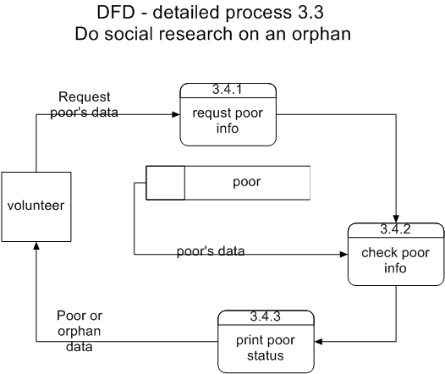

Detailed DFDs for the marriage and orphans helping sub-system with their descriptions:

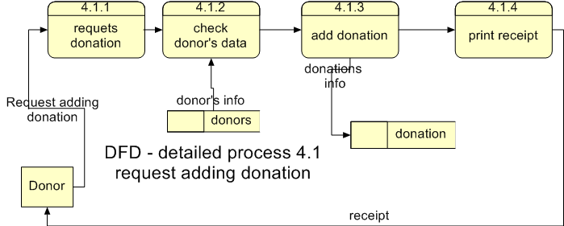

Process 4.1.2 check donor’s data
IF donor is registered
Accept donation
Else
Ask donor to register
End Process
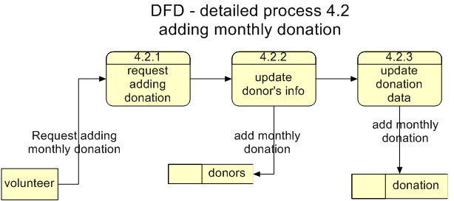

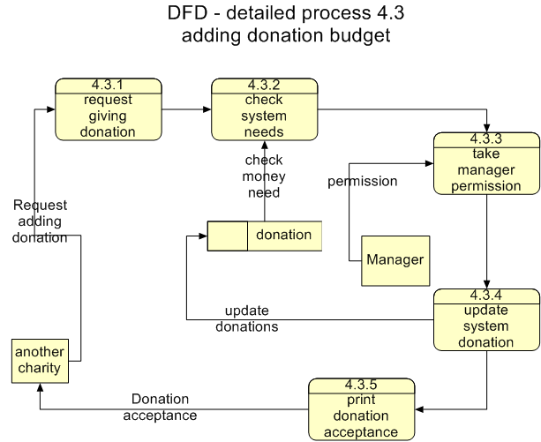
Process 4.3.2 check system needs
IF system has needs
Ask for manager permission
Else
Refuse help
End Process
Process 4.3.3 check manager permission
IF manager accepts donation
Accept this donation
Else
Refuse donation
End Process

Chapter 3

System Design

3.1 System Database Design:

Entities Determination
Relationships between Entities
Normaization

3.1.1 entity relationship diagram (ERD):
The ER-Diagram represents the overall logical structure of a database, which is independent of any software or data storage structure. The database of our system is shown in figure 3.1. This model describes the relationship among the tables.

Figure 3.1: ER Diagram
3.1.2 Tables Design:

1-AdminsTable:

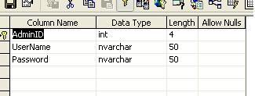

  - Table Columns:
- Admin ID: This is the number given to admins.
- UserName: This is the name that has to choose.
- Password: This is the password that the admin choose it.

2.

3.

4.

3.2 User Interface Design:

3.2.1 Summary of Screens (Pages)

3.2.2 Forms (Pages) Design

3.2.3 Reports Design

Chapter 4

System Implementation

4.1 Used Technologies

4.1.1 Database

4.1.2 Programming

4.1.3 Reporting

4.2 System Implementation Plan

4.2.1 Administration

The System administrator is responsible for controlling and managing the

Figure 4.1: Admin Login

4.2.2 Basic System Data (System Setup)

Figure 4.2: Add New XXXX

4.2.3 Transactions

Figure 4.3: XXXXXXXXXXX

4.2.4 System Messages

Message | Message No.

Chapter 5

System Testing

To test our system, we should start testing each page one at a time. All the pages are accessed and tested.

5.1 Testing Check List

Testing checklist for each page:

- The design of the page
- The links
- The menus
- The functionalities in the page
- The validation in the page
- Test page with random data

5.2 Test Cases

Form (Page): Sub:

Result | Value Entered | Attribute

Chapter 6

Future Work and Conclusion

The Project Team managed to develop

The team hopes that resources will be allocated in the future to implement and operate the system.

The following parts of XXXXXXX System were set aside for future implementation:
-
-
-

Appendix A: Project Source Code

Page 1:

Appendix B: Installation Guide

Appendix C: User Manual

